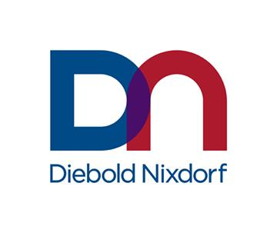
Press Release

Media Relations Investor Relations
Tiffini Bloniarz Maynard Um
+1 330 490 4499 InvestorRelations@dieboldnixdorf.com
tiffini.bloniarz@dieboldnixdorf.com

FOR IMMEDIATE RELEASE:
July 15, 2026

Diebold Nixdorf’s Vynamic® Transaction Middleware Recognized by Global Payments Awards
Cloud-native, API-driven platform honored by World Business Outlook and PayTech Awards 2026 for helping financial institutions modernize payments infrastructure

NORTH CANTON, Ohio – Diebold Nixdorf (NYSE: DBD), a world leader in transforming the way people bank and shop, today announced that its Vynamic® Transaction Middleware solution recently received two international recognitions for innovation in payments. The company was named Best Payment Solutions Provider Global 2026 by World Business Outlook and earned Highly Commended recognition in the Best Payments System for Banks and FIs category at the PayTech Awards 2026.
Vynamic Transaction Middleware is Diebold Nixdorf’s cloud-native, API-driven platform designed to help financial institutions modernize rapidly, eliminate siloed systems and deliver a smooth and consistent payment experience. It provides the core technology powering every payment interaction, including ATMs, POS terminals, mobile, web, branch, instant payments and card‑based transactions. Vynamic Transaction Middleware unifies issuing, acquiring, authorization and orchestration into a single platform.
Today, Vynamic Transaction Middleware is used by more than 80 financial institutions, supports more than 160,000 terminals worldwide and processes more than 20 billion transactions annually. In global deployments, the platform has helped institutions reduce operational complexity, streamline surrounding systems and accelerate time to market for new services while maintaining stability in high-volume payment environments.
Andy Zosel, Diebold Nixdorf executive vice president and chief technology officer, said: “These recognitions reflect the proven scale and flexibility of Vynamic Transaction Middleware, which helps banks and processors simplify complex environments, accelerate innovation and prepare for the continued evolution of global payments. They also reinforce Diebold Nixdorf’s success and strategy of expanding deeper into the branch by connecting payment capabilities with the broader banking experience.”
World Business Outlook Awards recognize and celebrate exceptional accomplishments, significant contributions, dedication, hard work and unwavering commitment to grow in the Business and Finance sector. The PayTech Awards, presented by FinTech Futures, celebrate innovation and outstanding achievements in the payments industry.

About Diebold Nixdorf
Diebold Nixdorf, Incorporated (NYSE: DBD) automates, digitizes and transforms the way people bank and shop. As a leading global technology and services partner to many of the world’s top financial institutions and retailers, our integrated solutions connect digital and physical channels for consumers conveniently, securely and efficiently. The company has a presence in more than 100 countries with approximately 20,000 employees worldwide. Visit www.DieboldNixdorf.com for more information.
X: @DieboldNixdorf
LinkedIn: www.linkedin.com/company/diebold
Facebook: www.facebook.com/DieboldNixdorf
YouTube: www.youtube.com/dieboldnixdorf

DN-B

###

